Sprint 2 Design Document

November 12, 2019

Use this Requirements Specification template to document the requirements for your product or service, including priority and approval (Must do).

This document will also serve as a System Design Document (How to) and will include sections detailing system flow, algorithms, staffing plan, software/hardware, and Test Plan

This document contains instructions and examples which are for the benefit of the person writing the document and should be removed before the document is finalized.

To regenerate the TOC, select all (CTL-A) and press F9.

Table of Contents

1. Executive Summary 3

1.1 Project Overview 3

1.2 Purpose and Scope of this Specification 3

2. Product/Service Description 3

2.1 Product Context 3

2.2 User Characteristics 3

2.3 Assumptions 3

2.4 Constraints 3

2.5 Dependencies 4

3. Requirements 4

3.1 Functional Requirements 5

3.2 Security 5

3.2.1 Protection 5

3.2.2 Authorization and Authentication 6

3.3 Portability 6

4. Requirements Confirmation/Stakeholder sign-off 6

5. System Design 6

5.1 Algorithm 6

5.2 System Flow 6

5.3 Software 6

5.4 Hardware 6

5.5 Test Plan 7

5.6 Task List/Gantt Chart 7

5.7 Staffing Plan 7

# Executive Summary

## Project Overview

Your robot must successfully run the figure eight course 5 times. A path will be laid out on the floor. Your robot must stay within the path provided. Your robot will start and finish in the square provided. Upon finishing, robot will speak ‘I am the winner’ and flash multicolored lights for 5 seconds. Points will be deducted if your robot strays from the path, if it does not go around 5 times, or if it does not finish in the same place it started

## Purpose and Scope of this Specification

This project is intended for educational purposes. The reason for the project is for students to become familiar with the principles of software design, and more specifically, how to work with the sphero robot.

# Product/Service Description

## Product Context

In order to test the limits of the sphero robot, the team has been tasked with developing a program that will make the robot do a figure 8.

## User Characteristics

Students will be using this product to practice their coding, organizational, and cooperative skills. The drag-and-drop block coding of the sphero app allows beginner coders to tackle a project using the robot without being overwhelmed.

## Assumptions

If the robot is not available for testing, the user would not be able to test the efficacy of their programming model. The unpredictable nature of the sphero’s movement makes creating models to predict its behavior extremely difficult. The spherical shape of the robot also creates a confounding variable in testing, where the simple physics of the robot make no two runs the same.

## Constraints

Describe any items that will constrain the design options, including

* Physical shape of the robot
* Limited command structure
* Limited access to the robot
* Commuter students
* Time constraints
* Lack of a standard measurement of distance
* Lack of a standard measurement of speed

## Dependencies

List dependencies that affect the requirements.

* Requires a sphero app account
* Requires Bluetooth connectivity

# Requirements

## Functional Requirements

|  |  |  |  |  |  |
| --- | --- | --- | --- | --- | --- |
| Req # | Requirement | Comments | Priority | Date Rvwd | SME Reviewed / Approved |
| Sp-01 | Robot has to perform a figure 8 |  | 1 |  |  |
| Sp-02 | The robot   stay reasonably within the path |  | 1 |  |  |
| Sp-03 | The robot should be as quick as possible, without sacrificing accuracy | Speed may be the name of the game, but if the robot cannot perform the figure 8 because of a speed that is too high, there is no point. | 3 |  |  |
| Sp-04 | The robot should avoid any obstacles | If obstacles apply, the robot should stick to the path so that it can avoid obstacles. It would be nice to be able to correct for a mistake due to an obstacle. | 4 |  |  |
|  |  |  |  |  |  |
|  |  |  |  |  |  |
|  |  |  |  |  |  |
|  |  |  |  |  |  |
|  |  |  |  |  |  |
|  |  |  |  |  |  |

## Security

### Protection

Periodic checks on the physical integrity of the robot are paramount. Along with this, making sure the code stays up to date to the robot’s abilities.

## Portability

JavaScript is a widely used coding language supported by most every modern device. Whether it is porting between computer operating systems, to mobile, or across robot models, the sphero app supports all modern operating systems and both iOS and Android.

# Requirements Confirmation/Stakeholder sign-off

|  |  |  |
| --- | --- | --- |
| Meeting Date | Attendees (name and role) | Comments |
| 11/5 | Brandon M., coder. Charles K., documenter. Luke M., planner/graphs. |  |

# System Design

This section will provide all details concerning the technical design, staffing, coding, and testing the system

## Algorithm

Develop and describe here the algorithm that will be used to provide the required performance of your software

1. Place robot on starting point

2. Set aim to 0 degrees

3. Set speed to x

4. Set Sphero to spin at 360 degrees for y seconds

5. Set Sphero to spin at -360 degrees for y seconds

6. Sphero return to start

7. Loop 4 more times

8. Speak “I am the winner”

9. Strobe red and green lights for 5 seconds

## System Flow

Develop a flowchart (and show here) that accurately depicts how your software application will act to fulfill the algorithm

## Software

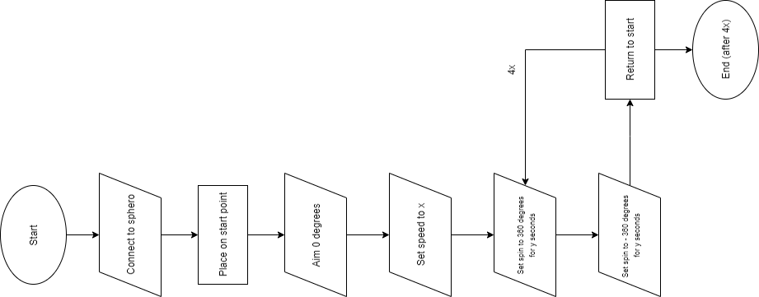

JavaScript is used on the back end, but block code through the sphero app was sued to code and test.

## Hardware

The sphero itself, two different laptops, and Bluetooth connectivity were used to perform the programs. Required for end users is any device that runs the sphero app, Bluetooth connectivity and a sphero unit are required.

## Test Plan

Include a test plan showing all unit tests performed for this application. Include test rational, test date, staff member, pass/fail status

5.5

|  |  |  |  |  |  |
| --- | --- | --- | --- | --- | --- |
| **Reason for Test Case** | **Test Date** | **Expected Output** | **Observed Output** | **Staff Name** | **Pass/Fail** |
| Measuring the angles in figure 8 | 11/ 5 | Measured angles | Measured angles | Brandon | Pass |
| Run the first semicircle | 11/5 | Stay on path and complete semicircle | Arced too far | “ | Fail |
| Run the first circle T2 | 11/5 | Stay on path and complete semicircle | Slowly stayed on path | “ | Pass |
| Run the second semicircle (bottom half) | 11/5 | Stay on path and complete semicircle | Off path slightly, skidded | “ | Fail |
| Run the second semicircle (bottom half) T2 | 11/5 | Stay on path and complete semicircle | On path, ran relatively quickly | “ | Pass |
| Reversed the previous semicircle group | 11/5 | Stay on path and complete last half of figure 8 | Stay on path and complete last half of figure 8 | “ | Pass |
| Test looping | 11/5 | Do figure 8 5x | Did 5 figure 8s, shifted slightly. | “ | Pass |
| Speak and strobe | 11/5 | “I’m the winner” and strobe | “I’m the winner” and strobe | “ | Pass |

## Task List/Gantt Chart



## Staffing Plan

Insert a chart/table that depicts the roles and responsibilities of each team member that worked on this project

| **Name** | **Role** | **Responsibility** | **Reports To** |
| --- | --- | --- | --- |
| **Brandon Merola** | Coder | Code and write about testing in design doc | Team |
| **Charles Klehr** | Design Doc | Set up design doc | Team |
| **Luke Medley** | Planner/Graphs | Planning materials and flowchart | Team |